1. 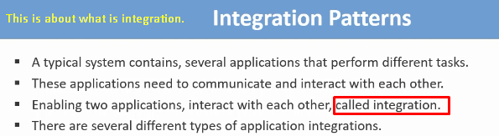
2. Let’s study types of integrations.
   1. **File-Based Integration**:  
      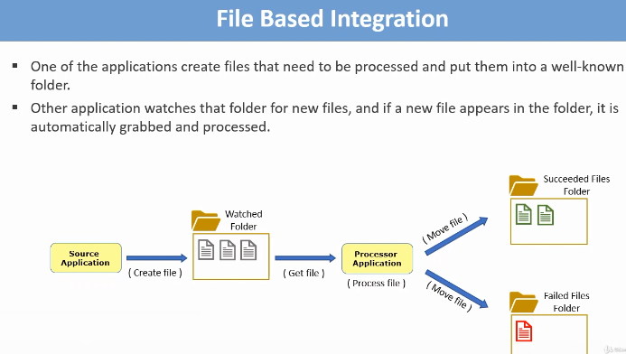
   2. **Shared Database Integration:**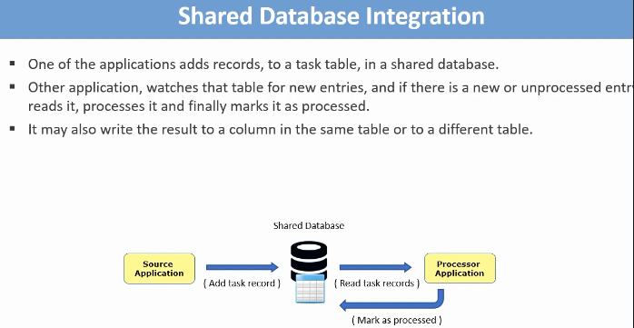
   3. **Direct Connection Integration:**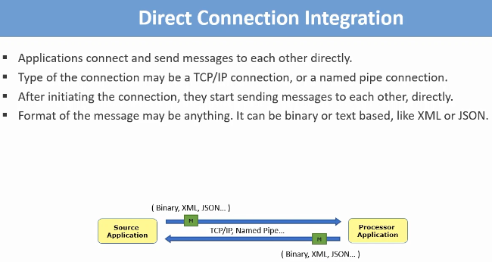
   4. **Asynchronous Messaging using Message Broker:**